DREXEL UNIVERSITY SPECIAL RATE $139

For reservations contact 877-646-6302 and mention the Drexel University Corporate ID #0560006063 or via booking link http://home2suites.hilton.com/en/ht/reservations/index.jhtml?hotel=PHLCCHT&corporateCode=0560006063
Hotel Features/Amenities
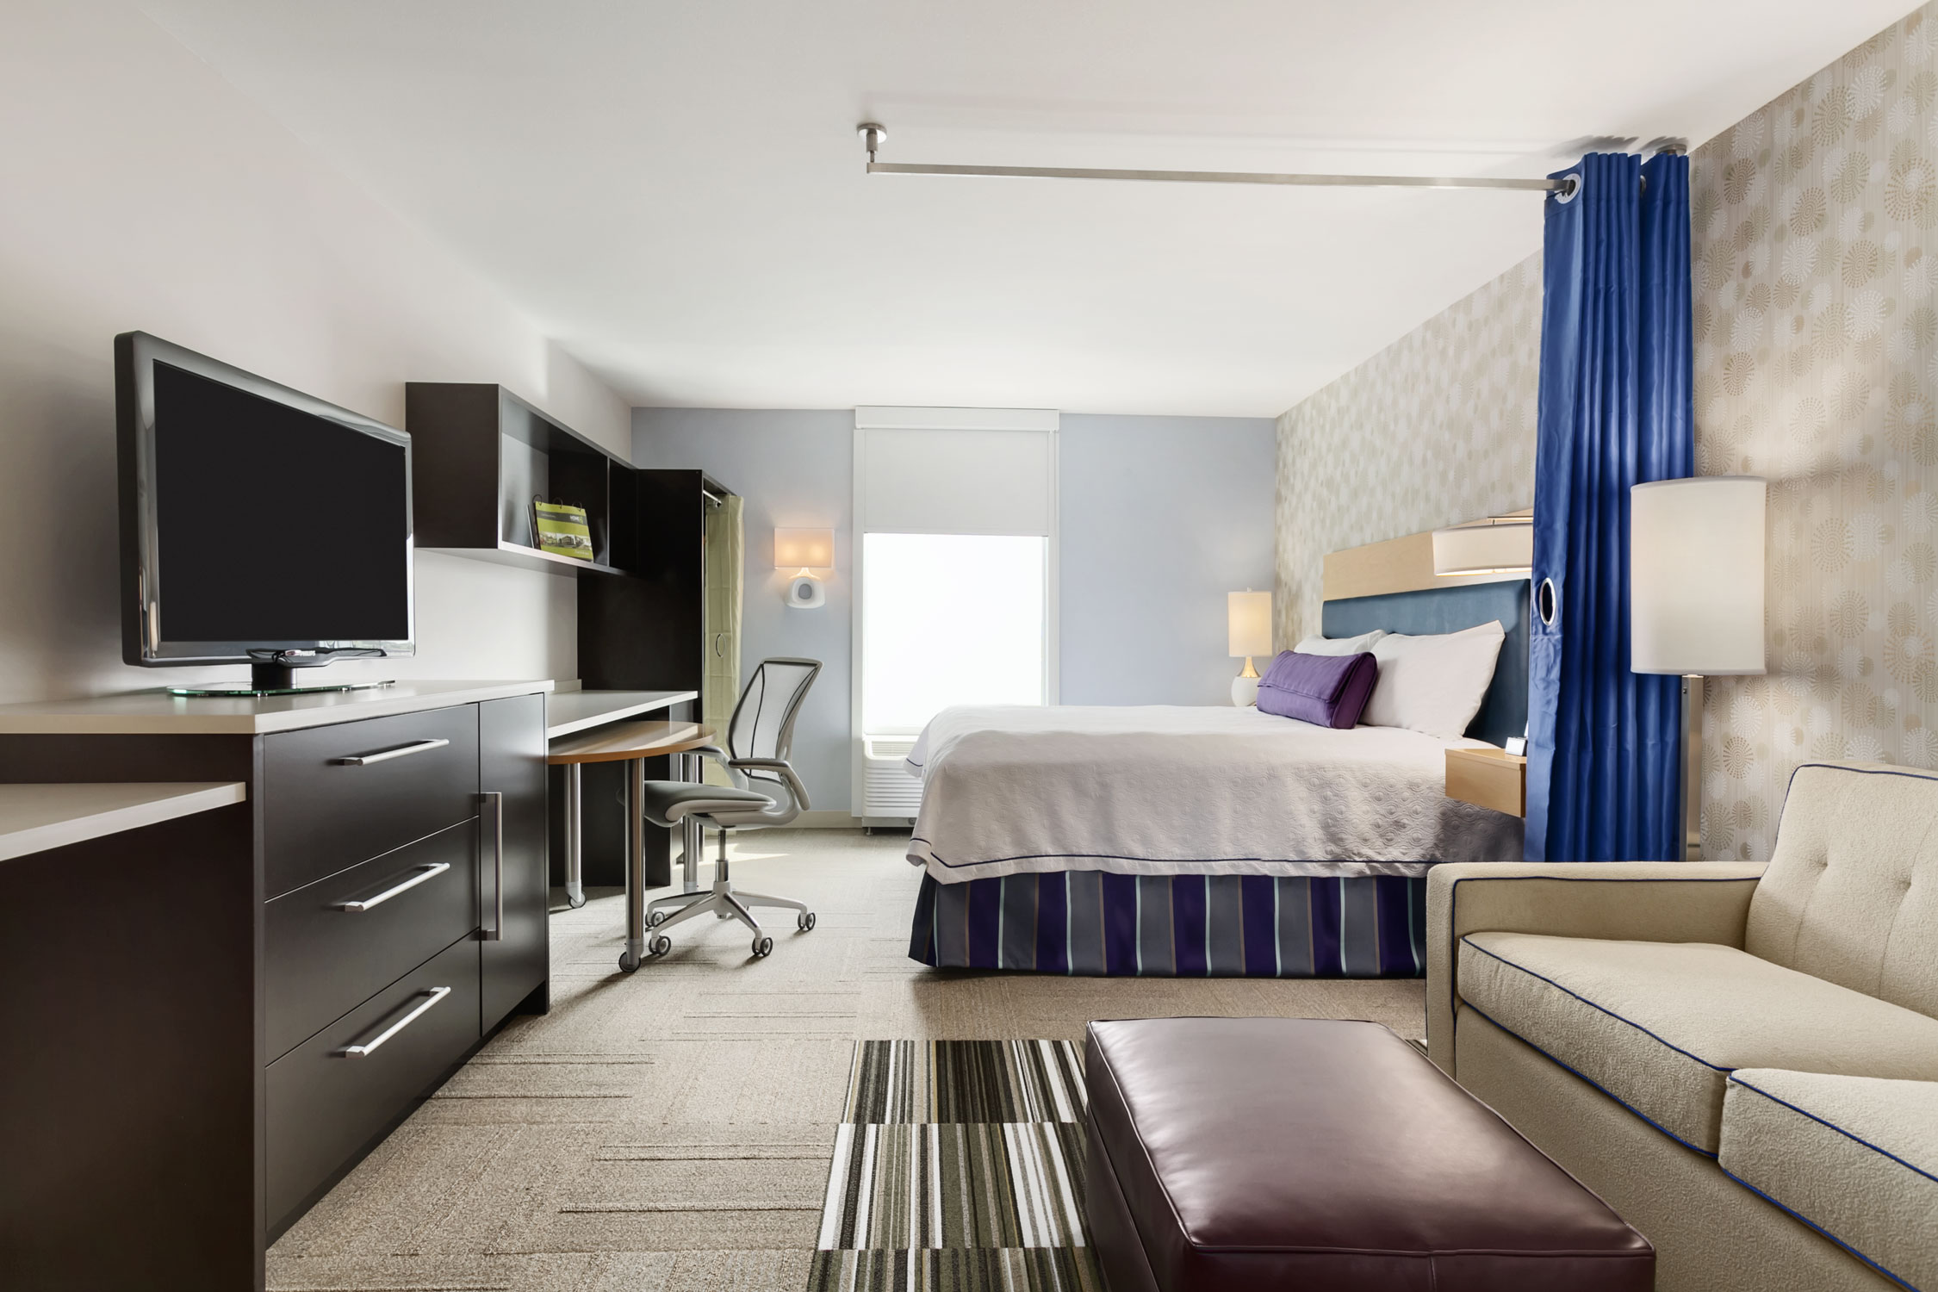
Philadelphia Convention Center 1200 Arch Street, Philadelphia, PA 19107

- All Suite Hotel with well equipped kitchens
- Free Inspired Table Continental Breakfast
- iHome® alarm clock with iPod® docking station
- Queen Size Sleeper Sofa in all Suites
- Saline Indoor Pool
- Spin2 Cycle Fitness/Laundry Facility
- Media Entertainment Room
- Complimentary High Speed Wireless Internet

Area Attractions
- Pennsylvania Convention Center (Adjacent)
- Reading Terminal Market (Across the Street)
Hotel Facts & Local Area Information
- Less than 2 miles from Drexel University
- Brand NEW Hotel, Opened August 6, 2013
- Largest Home2 Suites by Hilton with 248 suites
- First New Construction Hotel in Center City, Philadelphia in 10 years
- Self Pay Parking Garage located adjacent to hotel
- Septa Regional Rail-Market Street East,1 block from hotel
- 10 miles from Philadelphia International Airport
- Easily accessible from Interstates 95, 676 & 76

- City Hall
- Love Park
- National Constitution Center
- Independence Visitor Center
- Independence Hall
- Liberty Bell
- Philadelphia Museum of Art (& the Rocky Steps)
- The Philadelphia Zoo
- The Barnes Foundation
- The Betsy Ross House
- The Franklin Institute
- The United States Mint
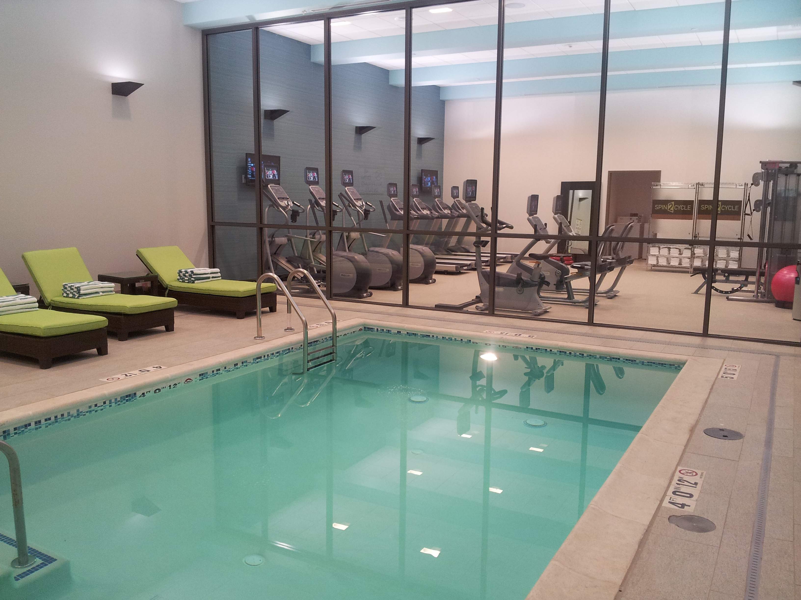
- Fairmount Park

Local Restaurants within Walking Distance
- Maggiano’s Little Italy
- Chili’s Grill & Bar
- Chinatown
- Panera Bread
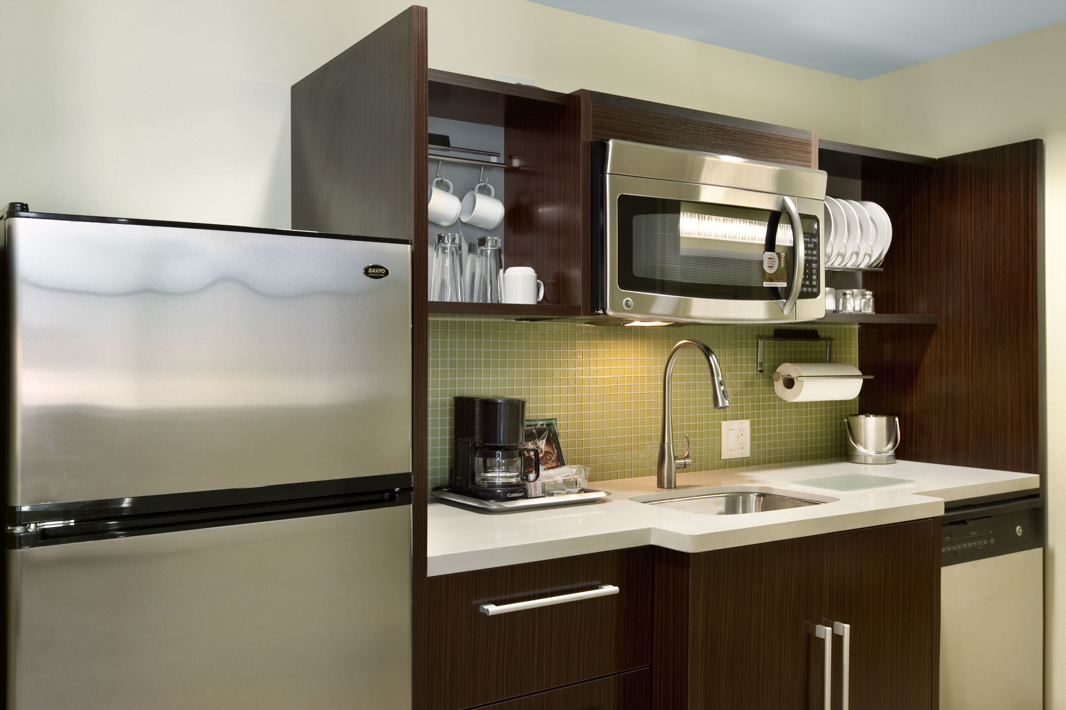
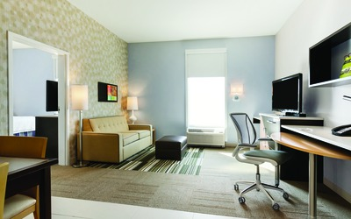
- Burger Fi
- Hard Rock Café
- The Capital Grille
- The Melting Pot
- McCormick & Schmick’s
- Barclay Prime
- Field House

