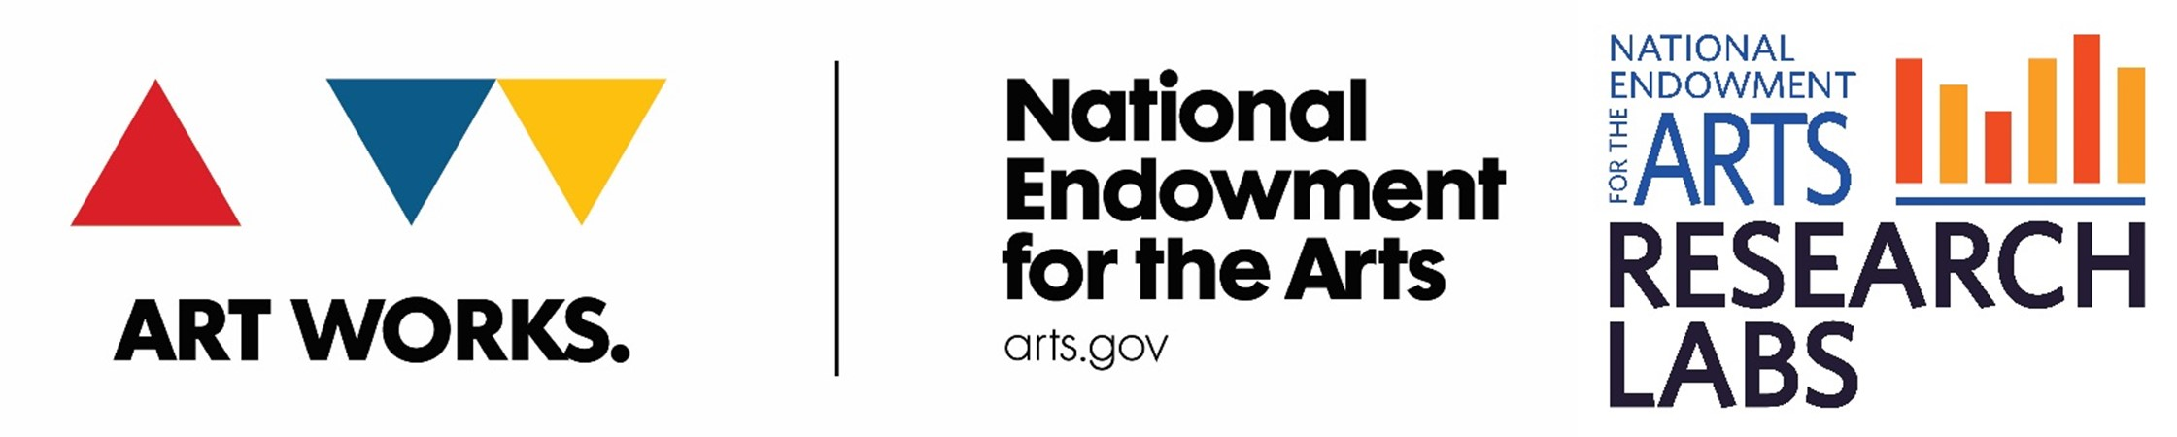
DEVELOPING AND SUSTAINING INTERDISCIPLINARY COLLABORATIONS IN ART THERAPY RESEARCH

Girija Kaimal, EdD, MA, ATR
Assistant Professor
Drexel University College of Nursing and Health Professions

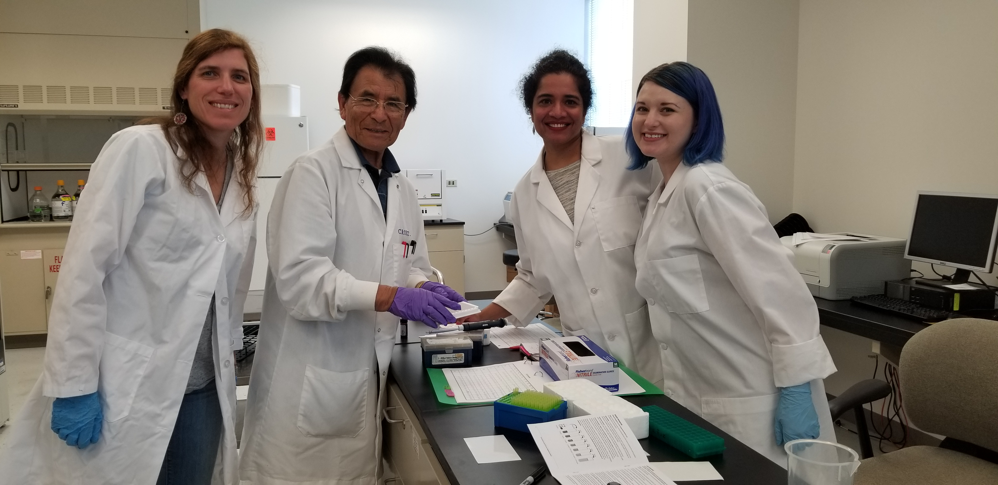
Image Description: The art therapy research team working to examine salivary samples at the Drexel University Department of Nutrition Sciences Lab. From left to right: Rebekka Hartwell, Dr. Juan Muniz, Dr. Girija Kaimal and Ms. Katrina Carroll-Haskins.

One of the studies being conducted as part of the Arts Research on Chronic Stress (ARCS Lab) NEA Research Lab, includes examining the outcomes of a short art therapy intervention for patients undergoing radiation oncology treatment and their caregivers.

Art therapy as a profession has from its origins in the 20th century been at the intersection of several disciplines including fine arts, psychology, education, rehabilitation, psychiatry, and, medicine. As a result, art therapy has been practiced in schools, hospitals, health centers, mental health settings as well as most recently in community health and wellness contexts. Research in the field has therefore drawn from different methodologies from the natural and social sciences (Kaimal, 2017). Scholarship in the field has been influenced by the case study model of medicine, as well as a small sample size (n), phenomenological and experimental traditions of the social sciences (Kaimal, 2017).

Art therapy has a rich clinical history and the focus on developing clinicians has resulted more in the establishment of systems for practice and education, and, less for research. Given the focus on clinical practice and limited funding for research, most art therapists have historically resourced their studies themselves and this has often limited the size and scope of the studies. Funding of the arts therapies including by the National Endowment for the Arts (NEA) Research Labs as well as the National Institutes of Health and the Department of Defense has helped in recent times to support larger studies.

To study how and why the arts therapies might help with a range of psychosocial needs, the field needs systematic studies that assess the processes and outcomes of art therapy. We need to understand what outcomes are affected as a result of the therapeutic interaction, what happens in the session (processes) that led to these outcomes, and, why the changes might occur (mechanisms of change) in the participants. These are tall orders for any research study and the days of one art therapist doing a small study on their own are not suited to the needs of the 21st century.

We need as a discipline to learn to work with other professionals to conduct comprehensive interdisciplinary studies that help us better understand what it is about the creative arts therapies that could be healing and also identify potential risks that we might need to consider when referring patients to art therapy. Interdisciplinary collaborations, although much needed for the creative arts therapies, can in reality be difficult to implement compared with staying within disciplinary boundaries and established methodologies (Kaimal, Barber, Schulman & Reed, 2012; Van Rijensoever & Hessels, 2011). Challenges include differences in values and beliefs about research methods; access to resources; research capacity; research priorities; and; perceived hierarchy in the status of different disciplines. To address these challenges of collaboration, Bronstein (2003) offers a model of collaboration that includes interdependence, newly created professional activities, flexibility, collective ownership of goals, and reflection on the process. In addition to this framework, we share below some lessons learned from a range of interdisciplinary studies conducted over the past ten years. Specific examples from the ARCS lab art therapy experiences and also included and summarized in the form of a set of reflective questions:

1. Am I ready to demystify the work done in art therapy?
Despite being a decades-old profession, art therapists are used to being unknown and needing to explain what they do to the lay public as well as professional collaborators. There are many misperceptions about the arts therapies including that anyone can do it including artists, psychologists, art enthusiasts etc. Often it helps to clarify that art therapy is a clinical care profession that requires a Masters degree in art therapy from an accredited program and a minimum of 1000 hours of supervised clinical training in order to practice as a clinician. Research in art therapy is even less known and researchers need to work with the assumption that they will need to clarify and explain the current scholarship in the field. It helps to not be defensive, rather to use opportunities to clarify how art therapy differs from the therapeutic art-making as well as, arts used for self-care practices. Art therapy researchers also need to define what they can and cannot do using resources like the media kit from the American Art therapy Association specifically the research resources page. In our (Drexel University) current research partnership with the National Endowment for the Arts, as one of their Research Labs, we are delighted to be working with the Radiation Oncology Unit at Penn Medicine where our partners are respectful of the arts (including some being active arts practitioners) and eager to establish the creative arts therapies as part of the clinical services and research efforts of the site. When we share our work or reach out to recruit participants, we all engage is explaining how the arts therapies are practiced and why research is essential to advance patient care. Not all partners have been respectful in past studies and those partnerships although developed with good intentions, have not eventually been sustained.

2. Does everyone on the team know their role?

In a successful interdisciplinary collaboration, members of the team know their respective roles and responsibilities. This includes awareness of individual and group timelines, access to information and resources, and, the required personal capacity to fulfill their roles. Moreover, even in a flattened hierarchy typical of research projects, it is important to know lines of reporting as well as, who plays the leadership role(s) in the research team. Partnerships are often created as part of a research proposal or funding opportunity. The proposal process itself can also be used as a way to gauge compatibility in the proposed team of collaborators. The key to an effective partnership is having complementary skills sets that make the collaboration stronger than the sum of its parts. For example, in our ARCS lab study, the partnership was initiated when the hospital site sought to bring in creative arts therapies as part of patient care. Although the initial partnership was established as a clinical affiliation, we were then able to leverage the affiliation for this research study. Currently the partnership is set us such that one partner brings expertise in art therapy interventions (Drexel University), another partner brings access to patients and physical space to conduct the study (Penn Medicine), and, two additional partners help with data analysis including statistical support (Drexel University School of Public Health) and biomarker data analysis (Drexel University, Department of Nutrition Sciences). These roles need to be respected with clear boundaries and cannot be replaced by any other partner on the team. The actual activities might change in the role, but the core responsibilities must not be changed without mutual agreement as a team. In the case of the art therapy study, most resource allocation decisions are made by the PIs. Data analysis is led by the key personnel serving on the study. Data entry, scheduling participants and implementing the individual sessions are areas that are led by the student research assistants (under the supervision of the PI as needed).

3. Can we communicate freely?

Intentional, efficient, authentic and frequent communication is essential to interdisciplinary partnerships. Given differences in organizational sizes, values, beliefs and goals, it is easy for misunderstandings to occur. For example, in our project we struggled initially to get institutional review approvals from both sites (Drexel University and Penn Medicine) as well as, setting up a space for the study. The project management responsibilities lies with the lead PI at Drexel University. Active, respectful, and organized communication via phone and email and in-person meetings with all the key personnel as well as administrative leads at both institutions helped establish the required approvals. In addition, this joint problem solving helped gather the members of the research team together as a group and helped us focus on our larger goals of implementing the study. In general, it helps to identify and address any problem as soon as possible. Having multiple ways to contact each other (phone numbers, emails, in-person etc.), openness to communicate helps reinforce working professional relationships.

4. What is in it for me?

To develop and sustain any partnership, it is important that each partner perceives a value for themselves, their department/group or institution. The lead researcher(s) need to ensure that all dissemination efforts include acknowledgment of relevant team members, and, equitable rewards for all partners. Interdisciplinary partnerships can be sustained only when all collaborators perceive value in the effort. If all the benefits are only reaped by one partner, it is unlikely that the partnership and interdisciplinary collaboration will be sustained. Taking time to learn from shared challenges and celebrating successes help sustain the collaboration. In our study, we make sure any presentations and publications include representatives from all partners and the funding agency as well.

5. Can I trust you?

Mutual respect can also be communicated with timely recognition of effort, gratitude and openness to new directions that the study might take. An effective way to develop and sustain trusting partnerships is to ensure that there is a larger goal of solving a societal problem that is beyond the individual aspirations of each partner. For example, in our study, our larger goal is the health and well being of patients with cancer and their caregivers. To that end, we were supported in this effort by the NEA, a federal funding agency which provides national visibility and legitimacy to the project. We then chose to bring together different resources that could promote the missions of our individual organization, albeit in very different ways. These partners and collaborators were brought together based on prior positive experiences of the lead researchers of the ARCS lab. Although institutional goals might at times places us at odds, these can be resolved if the overall goal leads the study rather than individual agendas. In addition we have two separate studies ongoing (art therapy and music therapy respectively) under the ARCS Research Lab, focused on different populations and approaches. Despite these differences in foci, through equitable distribution of funding resources and autonomy in implementation of the projects, they serve the mission of the overall ARCS lab.

In conclusion, interdisciplinary partnerships are key to conducting the types of large comprehensive studies that are needed to understand the impact of the arts therapies on various patient populations. Approaching the collaboration with a willingness to: educate, maintain mutual respect, trust, clearly define roles, communicate, share in success, and being led by a larger goal of working towards the health and wellbeing of our participants are some ways to develop and sustain interdisciplinary partnerships.

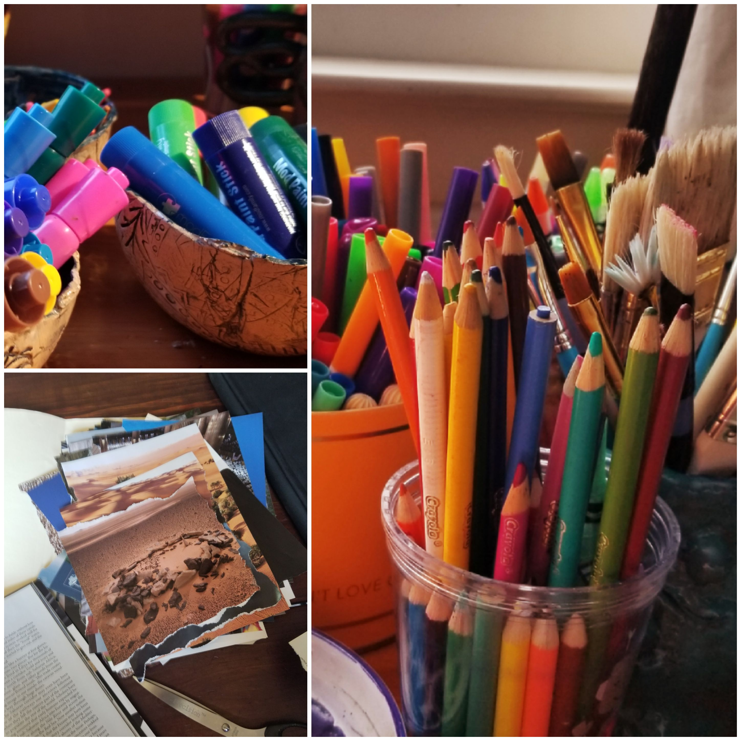
Image description: Some of the supplies used in the art therapy study (magazine collage, color pencils, markers)

References

Bronstein, L.R. (2003). A model for collaboration. Social work, 48 (3): 297-306.

Kaimal, G., Barber, M., Schulman, M., & Reed, P. (2012). Preparation of urban high school principals in Philadelphia through multi-organizational partnerships. Journal of School Leadership, 22, 5: 902-921.

Kaimal, G. (2017). The road ahead: Preparing for the future of art therapy research. In R. Carolan and A. Backos, (Eds.) Emerging perspectives in art therapy: Trends, Movements and Developments (pp. 58-74), New York: Routledge

Van Rijensoever, F.J., & Hessels, L.K. (2011). Factors associated with disciplinary and interdisciplinary research collaboration. Research Policy, 40 (3): 463-472.

