Please complete the module. See the information below for logging in and registering the first time.

Safety Training Module website: http://www.drexelehstraining.com

Please note the program has issues with apostrophes; therefore, if you have an apostrophe in your name, please leave it out.

Please use the following responses to complete the registration:

Log in and begin your training. If you have not previously used this training program please select the “New Here” button under the login box and follow the on-screen directions.

You will need to check and complete all types of materials below:

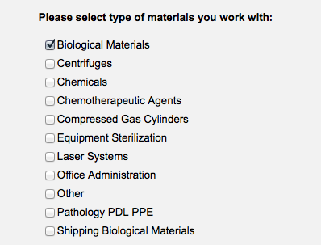

If you have questions or concerns, please feel free to contact Jeffrey Nemetz at jdn29@drexel.edu or Martin Bell at mwb32@drexel.edu.

