Exporting an SPSS Dataset into MS Excel format
These instructions will show how to export a dataset from SPSS 23 into MS Excel format. SPSS may also export to other data formats, including, Comma Separated Value Files (*.csv), Tab Delimited Files (*.txt) and others.

- Choose Save As….from the SPSS File menu.

- In the Save as type: dropdown menu, select Excel 2007 through 2010 (*.xlsx).

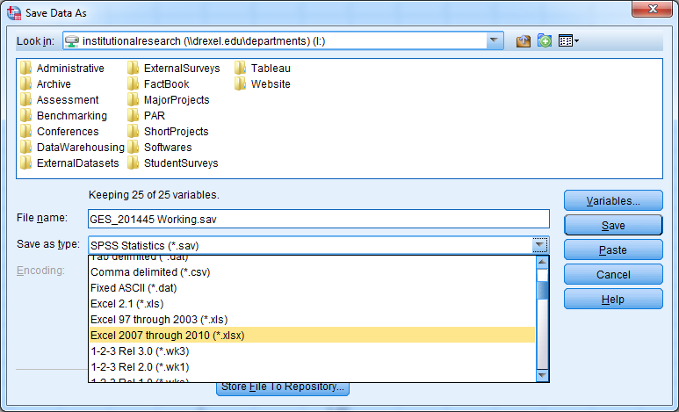

- If in your Excel file you would rather see value labels instead of the original values (example: ‘Very Satisfied’ instead of ‘4’), be sure to click Save value labels where defined instead of data values.
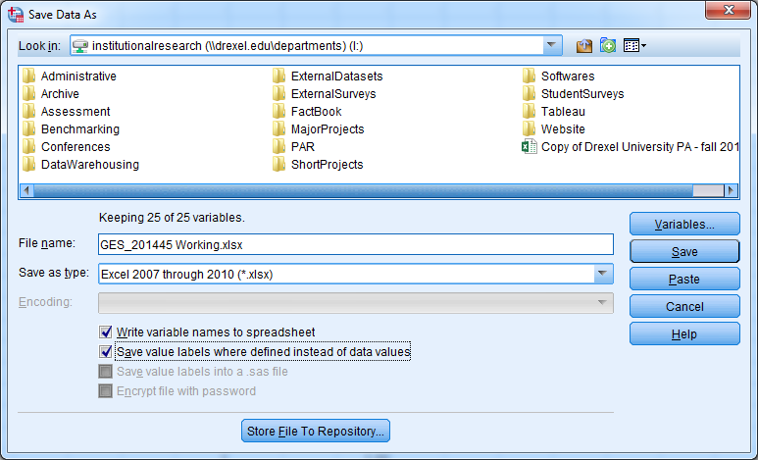

4. Then, enter the desired File name, and select Save.

